 by state and local governments earned between $67,700 and $69,840.

* Average Salary for Junior Environmental Data Analysts: **$47,158**
* Average Salary for Senior Environmental Data Analysts: **$96,809**

**Here are the top five states for environmental data analysis jobs:**

|  |  |  |  |
| --- | --- | --- | --- |
| **State** | **Environmental Scientists and Specialists employed** | **Average Hourly Wage** | **Average Annual Salary** |
| [**California**](https://www.bls.gov/oes/current/oes_ca.htm) | 14,830 | $ 45.62 | $ 94,880 |
| [**Texas**](https://www.bls.gov/oes/current/oes_tx.htm) | 5,770 | $ 40.43 | $ 84,090 |
| [**Florida**](https://www.bls.gov/oes/current/oes_fl.htm) | 5,270 | $ 29.08 | $ 60,490 |
| [**New York**](https://www.bls.gov/oes/current/oes_ny.htm) | 3,700 | $ 39.90 | $ 83,000 |
| [**North Carolina**](https://www.bls.gov/oes/current/oes_nc.htm) | 3,610 | $ 32.66 | $ 67,940 |

**What Is the Job Outlook for Environmental Data Analysts?**

The environmental data analyst job outlook is very positive. Jobs in the field of environmental data science are expected to continue growing according to the [Bureau of Labor Statistics](https://www.bls.gov/oes/current/oes192041.htm). There are about **87,100** environmental scientists (which includes environmental data analysts) employed in the U.S. with 7,300 more jobs likely by 2030.

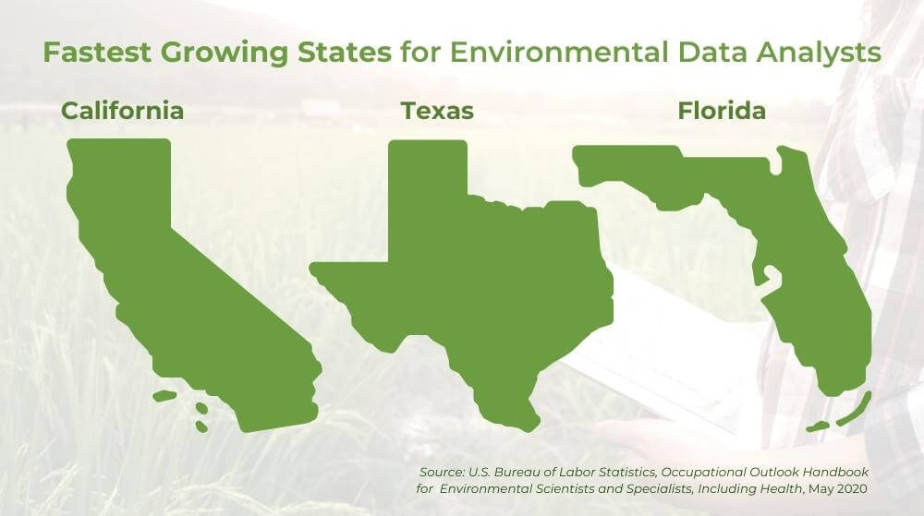

Increasing environmental concerns have created a high demand for jobs in the environmental science field. An environmental sustainability data analyst will find that employment opportunities are expected to grow in the next decade.

* Estimate of Jobs available: **87,100 employed**
* Rate of projected job growth: **8%**
* New jobs to be added in the next 10 years: **7,300**
* Fastest growing states for jobs: **California, Texas, Florida**

**What Education is Needed to Become an Environmental Data Analyst?**

You will need a four-year Bachelor’s of Science degree in Environmental Science or a related field, such as Biology or Ecology, to gain an entry-level position as an environmental data analyst. [Hands-on courses](https://unity.edu/unity-college-news/bolstering-hands-on-learning-with-professional-experiences/) in college will prepare you to master the essentials of environmental and ecological statistics and environmental data management. For those seeking advancement in the field, a Master’s degree in Environmental Science or a similar subject is necessary.

While obtaining a Master’s degree is not required to break into the industry, it is recommended. Candidates with a Master’s degree will be considered for senior-level roles. Those who wish to teach at a university will need a Ph.D. in a subject related to Environmental Science.

**Environmental Data Analyst High School Recommendations**

A high school student wondering how to become an environmental analyst should prepare for the STEM track. Study environmental sciences like Biology, Chemistry, and Physics. Additionally, students should take any classes that will help with analyzing data, such as Data Science and Statistics.

* Environmental Science
* Biology, Chemistry, Physics
* Data Science

**Environmental Data Analyst College Education Recommendations**

Environmental Science is key to environmental data analysis. Those interested in becoming environmental data analysts should pursue degrees in this field. Additionally, consider courses that focus on ecology, climate change, sustainability, and data science. All these areas create a strong understanding of environmental data analysis.

Undergraduate

A [Bachelor’s of Science in Environmental Science](https://unity.edu/programs/b-s-environmental-science/) is a great foundation for a career in environmental data analysis. This course teaches students about various ecosystems, and human impact on natural resources.

Postgraduate

A [Master’s in Environmental Science](https://unity.edu/programs/masters-environmental-science/) builds on what a student learns as an undergraduate. With this degree, a person will have a deep understanding of the physical and natural sciences. Additionally, graduates will have the knowledge they need to make well-rounded assessments and suggestions based on data analysis.

**Additional Certifications and Licenses**

Because Geographic Information Systems can play a large role in environmental data analysis, a [Graduate Certificate in Environmental Geographic Information Science](https://unity.edu/programs/environmental-geographic-information-science/) can be useful in the field. This certificate equips students with data management experience. Additionally, having an environmental data analyst internship on your resume may help you break into the field faster.